

**Dozentur   
Produktion und Logistik**Priv.-Doz. Dr. Rainer Kleber

Project Report

Lecture Business Forecasting

Mine Case 1

Showmik Das

ID : 220613

Ghislain Karrel Djeukou Nouendoui

ID :223882

Thi Tram Anh Trinh

ID : 221563

# I Table of Contents

I Table of Contents II

1. Introduction 3

2.1 Initial data analysis 3

2.2 Selecting an appropriate forecast method 3

2.3 Performance method and the comparison with the benchmark method……………...5

2.4 Finding out different estimation sample for better prediction interval……………….5

3. Conclusion………………………………………………………………………………...5

Appendix 6

# 1. Introduction

## We are asked to perform one step ahead forecasts of total US retail sales for January 2016 as the decision maker . Our primary objectives are as follows:

* Developing appropriate forecast method for the given series.
* Using an appropriated benchmark method and compare the performance of the methods.
* Finding a different estimation sample for better prediction interval.

**2.1 Initial data analysis:**

We have the data of US retail sale from January 2001 to December 2015. We try to decompose the components of the data .

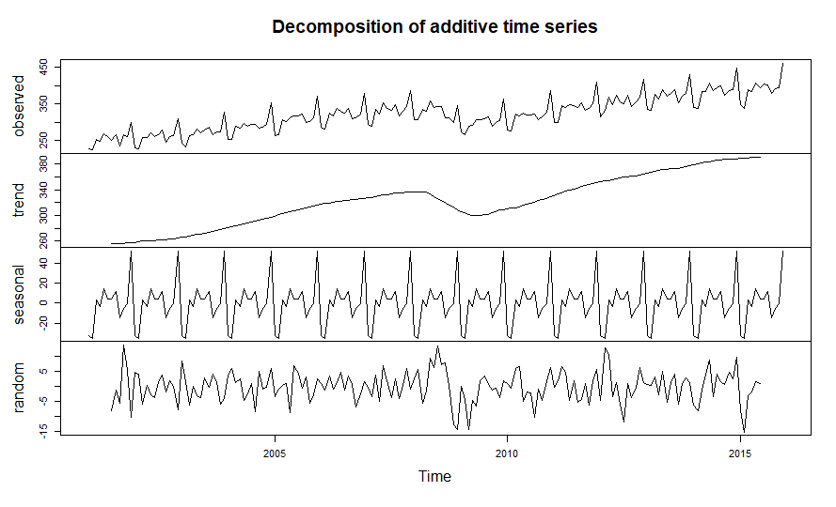Fig 1 : Decomposing the initial data to understand the components of the time series

The figure represents the trend , seasonality and the random error of the given data. The trend is somewhat linear behavior which transformed into a damped trend around year 2008 because of the great recession. There are significant peaks in regular interval which shows strong seasonality in the data . As the time series increases in magnitude , the seasonal variation increases as well . So the seasonality is multiplicative in nature.

We are also asked to consider the data till Dec 2012 as the estimation sample.

**2.2 Selecting an appropriate forecast method:**

After the initial data analysis, our task is to select the appropriate forecast method which will consider all the three components(trend , seasonality and random errors )of the given data . We rule out simple exponential smoothing because it produces forecasts that lag behind the actual trend .

The following forecasting methods are used to achieve our objectives :

* **Exponential smoothing with damped trend**
* **Additive/Multiplicative holt winters method (with damped trend)**

We perform all our calculations in R . ( We also performed Ses , Les, Add/multi holt winters which are shown in the Appendix)

Fig 2 : graphical representation of forecast with damped exponential smoothing

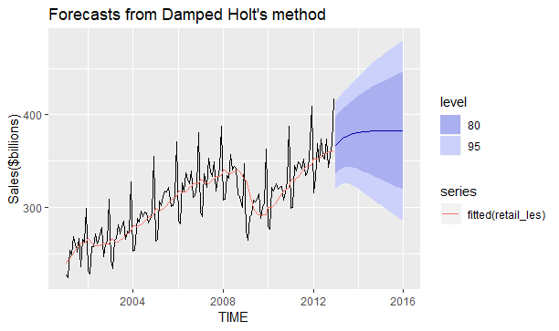

Here we can see that exponential smoothing with damped trend somewhat captures the trend of the data but cannot fit the data for the seasonality. So to acknowledge the seasonality we invoke the holt winters multiplicative method .

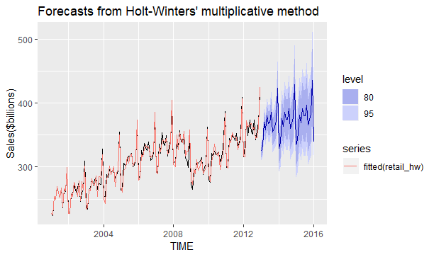Fig 3 : graphical representation of forecast wit holt winters multiplicative method

The graph denotes that the method successfully captured the multiplicative behavior of the seasonality and thus reflects the forecast in the similar manner to the given data.

**2.3 Performance measure and comparison with the benchmark method:**

As the initial data shows a strong seasonality, we chose the seasonal naïve method and compare it with the results we got from our calculation. We perform the rolling forecast error for the hold out sample (Jan 2013 to Dec 2015) and select the method with the lowest route mean squared error .

|  |  |  |  |  |
| --- | --- | --- | --- | --- |
| Forecast Method | RMSE | MAE | MAPE | Point Forecast |
| Seasonal Naive | 17.893 | 15.263 | 2.900 | 348.575 |
| SES | 28.333 | 21.280 | 5.549 | 406.609 |
| LES | 30.781 | 19.721 | 5.152 | 400.253 |
| LES(damped) | 27.390 | 19.72 | 5.152 | 399.496 |
| Hw add | 6.434 | 5.340 | 1.405 | 362.131 |
| Hw add (damped) | 7.208 | 5.340 | 1.405 | 372.705 |
| Hw multi | 5.650 | 4.625 | 1.218 | 358.518 |
| Hw multi (damped) | 5.243 | 4.625 | 1.218 | 358.669 |

Table 1 : Performance measurement of all forecasting methods performed

We find that the multiplicative holt winters method performed the best in terms of the lowest route mean squared error .

**2.4 Finding out a different estimation sample for better prediction intervals:**

We try to perform our calculation with three different estimation sample in the holt winters damped multiplicative method and compare the prediction intervals in the given table .

|  |  |
| --- | --- |
| Estimation sample | **Prediction Interval** |
| 01/2001-12/2012 | [255.56 , 430.78] |
| 01/2010-12/2013 | [287.20 , 404.49] |
| 01/2004-12/2014 | [316.98 , 394.62] |

Table 2: Different prediction intervals for different estimation sample size

**3. Conclusion :**

For the given data set , holt winters multiplicative (damped trend) method performs the best and for different estimation sample we get different prediction interval and the interval is smaller when we include most recent data in our estimation sample .

**APPENDIX:**

1. Simple exponential smoothing :

Alpha = 0.2097 , Point Forecast=406.60 , RMSE= 28.3395

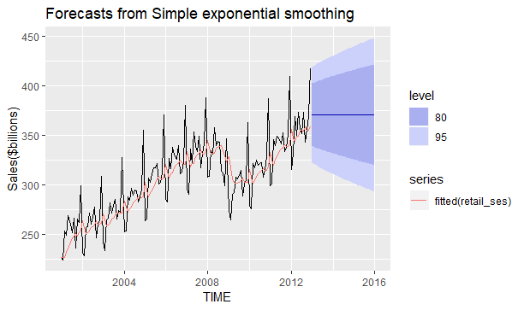

Fig: Graphical representation of simple exponential smoothing forecast method

1. Linear exponential smoothing :

Alpha= 0.2097, Beta=0.1163, Point forecast= 420.887 RMSE=27.39



Fig : Graphical representation of linear exponential smoothing forecast method

1. Additive holt winters method :

Alpha=0.6323 , beta=0 ,gamma=0.4087 , Point forecast=362.131 , RMSE=6.43

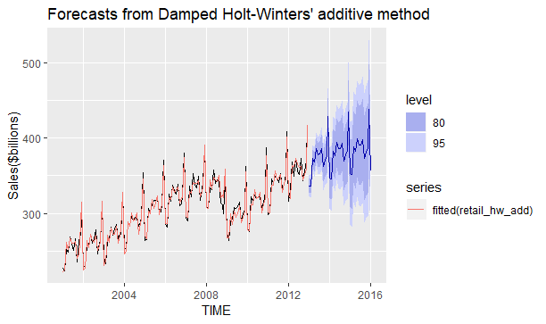

Fig : graphical representation of additive holt winters method